MANNA FOR HEALTH: SAFE HARBOUR CREATED, COMMUNITY SUSTAINED

Manna for Health is a safe, respectful and dignified food and nutrition resource centre for those living with HIV/AIDS and other life threatening illnesses, operated entirely by volunteers. We are an organization created by Safe Harbour MCC and sustained by the community. Manna for Health is truly a community owned institution.

As the director for Manna, I want to take this moment to say thank you for your generous contributions in 2010. In addition to the food we received as a member agency of Feed Nova Scotia, we received $11,256 in additional cash and in-kind donations.

These donations included a $3,000 grant from ACE Bakery, $1,500 from the Imperial Sovereign Court Atlantic Nova Society. (ISCANS), $2,450 from the Aids Walk, and the remaining $4,306 came from congregational and other donations, fundraising and donations in- kind . Special thanks go out to ISCANS, MZ. Vickie, Doug, Dave and staff at Menz, and all who worked the fund raisers and those who gave to Manna. Thank you, Thank you, Thank you.

As it was reported this year in the Globe and Mail and the Chronicle Herald, Manna is truly unique in two ways. One, we spent an additional $9,021 to provide our clients with the nutritional resources needed for those who have compromised immune systems (a choice of beef, chicken, pork and fish protein, butter, milk and when available cheese, peanut butter, eggs and Boost) and other needed items. The second thing that makes us relatively unique is that we personally deliver to those who are unable to travel to our onsite location.

After a year on the job, I have come to understand that Manna does indeed belong to the community and we, the volunteer staff, are simply stewards of this most important institution. I am grateful that you entrust us with such profound responsibility and assure you that we stand ready for the challenges ahead in 2011.

This year I am proud to report that 85% of expenditures went directly to client services (food purchases, delivery and bus ticket costs) and the remaining 15% to administration and operating costs (rent, telephone, insurance, repair and maintenance).

We expect the repair and maintenance cost will virtually disappear this year due to the efforts of Janice Costigan and the Bank of Montreal (BMO). Janice, a senior facilitator for BMO, heard me worrying (rather loudly) about the additional cost of repair on the old refrigerator and the health risk this might impose on our clients. We were throwing away a lot of food on those days the refrigerator was broken. Unannounced to me, Janice emailed the office of the District Vice President for Atlantic Region and three weeks before Christmas we received a new refrigerator freezer. I was humbled at the spirit of giving and thrilled to have received such a gift from BMO. Thank you Janice and thank you Bank of Montreal (BMO) for a wonderful life giving surprise.

It is no surprise that all of us have seen an increase in our family food budget and Manna was no exception in 2010. We had to dip into our savings this year to make up for additional food, bus ticket and delivery costs of $3,389 over the 2009 expenditure level. Your contributions made up for all but $1,023 of that additional cost. As we know from managing our family budgets, it’s times like these that our savings accounts are very important.

As we plan for 2011, I assure you that we are dedicated to being responsible ambassadors for the health and welfare of our clients as well as good stewards of your donations. I personally look forward to this next year knowing that together we will continue to make a difference. Thank you again everybody, it was indeed a good year for Manna.

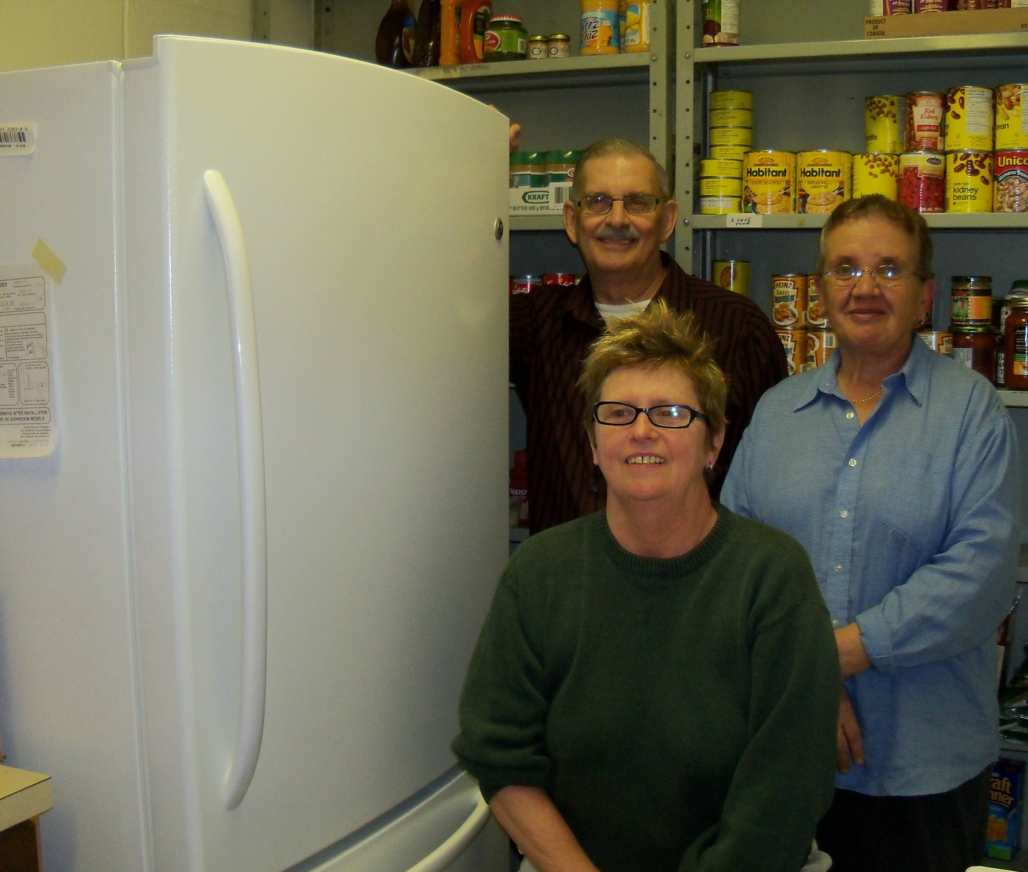

Manna for Health food distribution volunteers Dave Bird and Helen Langille
with Rev Jen and the new refrigerator donated by Bank of Montreal (BMO)

