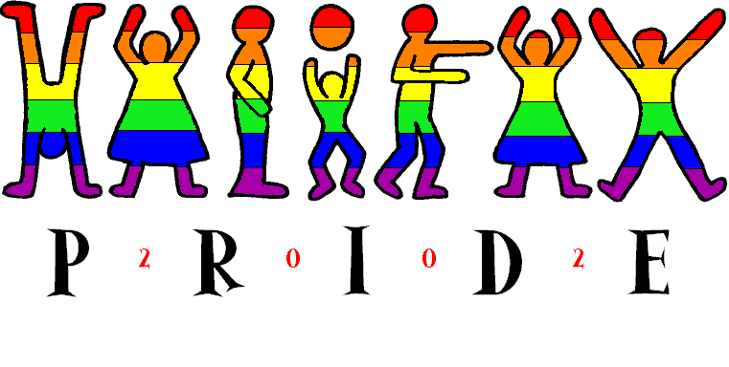
Proud Supporter
July 20/02Halifaxpride.org

Halifax Pride 2002 Proud Sponsor Decal at full size. Final design may vary slightly.

Grand Sponsors:
$2000.00 or $3000.00 in products and services

- Halifax Pride 2002 Proud Supporter window decals;
- Your logo prominently on a sign thanking our sponsors at our main events.
- Your logo on all official Halifax Pride Committee Press releases and correspondence;
- Your name acknowledge during CKDU All Day All Gay program;
- Your name acknowledge at all major Pride Events;
- Your name associated with a major Pride Event;
- Your logo displayed prominently on official Pride Week Posters;
- Your logo on individual event posters displayed at least 2 weeks in advance at the various Club and other locations where events are taking place;
- Your logo on all Pride Week advertisement Street Banners;
- Your logo with link on our web site;
- Your logo on our Big Event Party Tickets;
- Your logo on our Pride Week Event Passport;
- 6 VIP tickets to various Pride events;
- Your logo in the Pride Guide Supplement;
- Grand Sponsor Recognition in the Coast Pride Supplement;
- Your banner displayed at major Pride events.

Major Sponsors:
$1000.00 or $1500.00 in products and services

- A Halifax Pride 2002 Proud Sponsor window decal;
- Your logo on a sign thanking our sponsors at our main events.
- Your logo on all official Halifax Pride Committee Press releases and correspondence;
- Your name acknowledge during CKDU All Day All Gay program;
- Your name acknowledge at all major Pride Events;
- Your logo displayed on official Pride Week Posters;
- Your logo on individual event posters displayed at least 2 weeks in advance at the various Club and other locations where events are taking place;
- Your logo on Pride Week Street Banners;
- Your logo with link on our web site;
- 2 VIP tickets to a Pride event of your choice;
- Your logo on our Pride Week Event Passport;
- Your logo in the Pride Guide Supplement;
- Major Sponsor Recognition in the Coast Pride Supplement;

Secondary Sponsors:
$500.00 or $750.00 in products and services

- A Halifax Pride 2002 Proud Sponsor window decal;
- Your logo (half size) on a sign thanking our sponsors at our main events.
- Your name acknowledge at all major Pride Events;
- Your logo (half size) displayed on official Pride Week Posters;
- Your logo on individual event posters displayed at least 2 weeks in advance at the various Club and other locations where events are taking place;
- Your logo with link on our Halifax Pride Sponsorship web page;
- Your logo in the Pride Guide Supplement;
- Sponsor Recognition in the Coast Pride Supplement;

Simple Sponsors:
$100.00 or $150.00 in products and services

- A Halifax Pride 2002 Proud Sponsor window decal;
- Your name listed on Halifax Pride Sponsorship web page; and
- Name listing in the Coast Pride Supplement.

