Insert logo and Theme: page 4

Demographics

Each year there is consistency in the added exposure of Halifax Pride through the increase of visitors, parade spectators, and participants. The parade route is mapped out within the heart of downtown Halifax and injects excitement and celebration into the spirit of everyone.

- 2003 spectatorship ranged at 13,000 with 4000 parade participants.
- 2004 spectatorship ranged at 18,000 with 4200 parade participants.
- 2005 goal to reach over 23,000 spectators and 5000 parade participants.

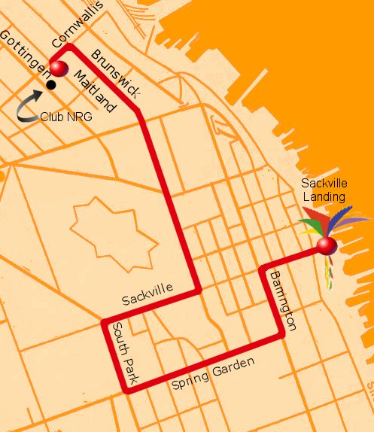

Halifax Pride has increased the marketing value of your sponsorship commitment by implementing a strong media plan to include print and web advertising within many areas in Canada, the US and Europe. It is our commitment to We have chosen a variety of LGBT publications, various weekly news magazines, websites, and travel newsgroups. Our plan is to increase our marketing budget to allow more dollar value as our sponsorship fulfillments increase. We understand the need of added value for your sponsorship commitment in order to maintain a return on your investment.

Testimonials

Dawn Sloan – Councillor, District 12 - HRM

“Pride festival is not just a celebration for individuals, it’s a celebration of life itself. Past experiences have been a catalyst in making this what is now a signature event for the HRM and the province of Nova Scotia.”

Mike Velemirovich, - Hillcrest Volkswagen “The Halifax Pride Committee is well run and is easy to do business with. They understand and embrace the concept of "under-promise and over-deliver" which only adds to value we have received over the years in the gay and lesbian market.”

Theaston White – Convergys

