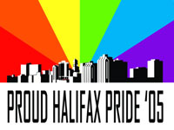

Sponsorship Contract

Molson Canada

And

Halifax Pride Committee

Re: Grand Sponsorship Position for Halifax Pride 2005

Halifax Pride Provides:

- Your logo and a display ad in the Halifax Pride Event Guide in The Coast
- Your logo displayed within all event posters and advertising – both Maritime and National. Your name associated with the RuPaul concert at Reflections Cabaret, July 23rd, 2005
- Your name on all official Halifax Pride Committee Press releases and
correspondence
- Your name acknowledged at all major Pride Events
- Your logo with a link on our website to yours
- Your name acknowledged during CKDU "All Day All Gay" program
- Halifax Pride 2005 Proud Sponsor window decal

Molson Provides:
- $2000.00 cheque
- Ad for display in Halifax Pride Event Guide – contact Lee Bent 423.9930
- Coors Light gear and giveaways – tbd
Signed this date ______________________
__________________________ _____________________________
Molson Canada Halifax Pride

