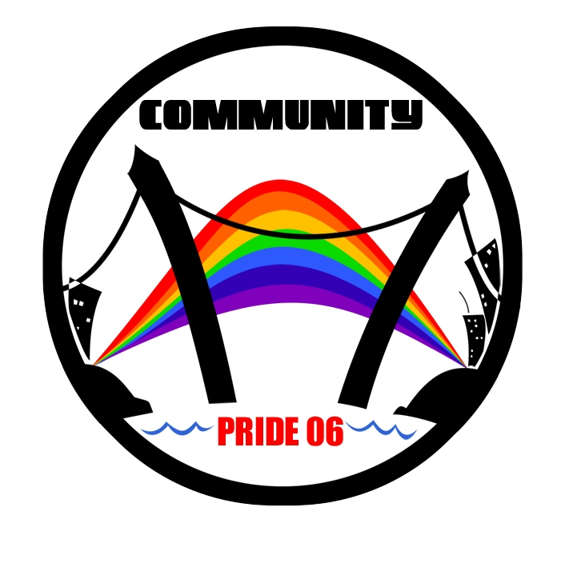
Halifax Pride Committee 2006

2281 Brunswick Street

Halifax, Nova Scotia B3K 2Y9

Phone: (902) 429-5429 Fax: (902) 423-7735

Dear Potential Sponsor,

Halifax Pride is now the largest festival of its kind in Atlantic Canada, bringing in visitors from across the Maritimes, and all of North America. This year’s Pride Parade will rely on hundreds of volunteers, boast as many as 6,000 participants, and will draw between 20 and 25,000 spectators! Our sponsorship packages are designed to put you in touch with this exciting market.

Statistically gay and lesbian consumers are well educated and affluent, loyally supporting the businesses that support them. The Lesbian, Gay, Bisexual, and Transgender (LGBT) community is the best asset that Halifax Pride can deliver to you, our sponsors.

All our sponsorship packages are flexible. We’re ready to work with you to custom-build a package that’s tailored to fit your organizations needs and budget.

This year, as in previous years, we will be marketing Halifax Pride as a premium travel destination via a targeted media campaign to key Canadian and U. S. markets. As we build on past successes, we look to our business partners for financial support. Together we can achieve our goal of making Halifax Pride 2006 bigger, brighter and bolder than ever before.

Should you have any questions please contact us at the above address, or you can e-mail us at sponsorship@halifaxpride.com .

Thank you for your time and consideration.

Patrick Daigle & Hugo Dann
Co-Chairs Halifax Pride 2006
5 Great Reasons to Support Halifax Pride

1. We’re Bigger and Brighter and Bolder than Ever!
Seven days of terrific events: arts and cultural programming, a film festival and comedy night; and a free concert on Halifax Commons! There’s something for everyone, with fun and excitement for the whole Halifax family. Halifax Pride is the largest GLBTQ east of Montreal, climaxing in the second largest parade (after the “Parade of Lights”) in HRM.

2. Look Who’s Coming to Play with US!
With an expected audience of 20 to 25,000 people, Halifax Pride can put your company in the spotlight like no other event in the city. Pride draws a crowd that is sophisticated and urban; that bridges the gaps of generation, culture and sexual orientation; bringing everyone together in a celebration of human diversity.

3. Our Theme in 2006 is Community!
Halifax Pride is the unifying strand in the fabric of lesbian and gay life in Nova Scotia. We strive to be connected with all our community’s organizations and groups. While most of our events are free of charge, all others are held in conjunction with charities and service organizations that benefit our community. Pride would not take place without the support of these groups and the hundreds of volunteers who make it all possible.

4. Our Community is Watching!
Pride Week is more than just a parade and party. Pride is an event that engages our whole community; one we care deeply about. When you sponsor Pride, we notice and we give back. With more than 2.6 million Canadians identifying as gay or lesbian and another 7 million as bisexual, this lucrative market has been valued at between 50 and 70 billion dollars in Canada alone. If you are operating at a national or North American level, a sponsorship of Halifax Pride will get you noticed beyond Atlantic Canada!

5. Great Return on Your Investment!
The LGBTQ community is heavily brand identified. Surveys have shown as many as 89% will go out of their way to use products and services from businesses that support the LGBT community. With all the media exposure that Halifax Pride can deliver, your company’s name and product is guaranteed to make an impact.

“The Halifax Pride Committee is easy to do business with. They understand the concept of ‘under-promise and over-deliver’, which only adds to the value we have received over the years from the gay and lesbian community.”
- Mike Velemirovich, Hillcrest Volkswagen

HALIFAX CITADEL EVENT SPONSOR - $5000 +

As Halifax Citadel sponsor you will have your business name and logo attached to a Halifax Pride Event of your choice*. You will be eligible for exclusivity within your line of business**. You will also receive:

- Half-page colour ad in the Pride Events Guide (your choice of inside front or back cover*)
- Opportunity to be a keynote speaker at your Pride Event.\
- Your logo identifying you as Halifax Citadel Event Sponsor on our website, with a link to ours
- Banner space at the Festival site on the Halifax Commons and on appropriate Event signage
- Your name and logo featured on all Halifax Pride media releases and promotions
- VIP tickets to the Pride Parade and all Halifax Pride Week Events
- Invitation to Halifax Pride 2006 media launch
- Free Parade and Festival site exhibitor registration
- Halifax Pride 2006 Proud Community Sponsor window decals

Media value of approx. $20,000

BLUENOSE II SPONSOR - $2500 +

As a Schooner Bluenose Sponsor your business name and logo will appear in all local and national promotions. Your name will be eligible for association with a specific Halifax Pride Event*, along with:

- A quarter page ad in the Pride Events Guide
- Your name and logo on our website, with a link to yours
- Your name and logo on all Halifax Pride 2006 media releases
- Your name and logo on all appropriate event signage
- Invitation to our media launch
- VIP tickets to the Pride Parade and all Festival Events
- Free Parade and Festival Exhibitor registration
- Halifax Pride 2006 Proud Community Sponsor window decals

Media Value of approx. $12,000

POINT PLEASANT COMMUNITY SPONSOR - $1000 +

As a Point Pleasant Community Sponsor you will receive VIP tickets to our Pride Parade; plus:

- A business card sized ad in the Pride Events Guide
- Your logo on our website, with a link to yours, identifying you as
Point Pleasant Community Sponsor
- An invitation to our media launch
- Your name acknowledged at all major Halifax Pride 2006 Events
- Two tickets to Halifax Pride events
- Free Pride Parade and Festival Exhibitor registration
- A Halifax Pride 2006 Proud Community Sponsor window decal

ALDERNEY GATE SPONSOR - $500 +

As Alderney Gate Sponsor, you will receive the following:

- Your logo with a listing as Alderney Gate Sponsor in the Pride Events Guide
- Your logo as above on our website acknowledging your support
- Your name acknowledged at all major Halifax Pride Events
- Free Parade and Festival Exhibitor registration
A Halifax Pride 2006 Proud Community Sponsor window decal

CRYSTAL CRESCENT SPONSOR - $100 +

- Listing as Crystal Crescent Beach sponsor in the Pride Events Guide
- Your name listed as Crystal Crescent Sponsor on our website
- Free Festival Exhibitor registration
- A Halifax Pride 2006 Proud Community Sponsorship

All our packages are flexible and can be custom-designed to suit your organization’s needs and budgets. Please don’t hesitate to contact us at our office by phone (902) 429-5429 or via e-mail: sponsorship@halifaxpride.com

- *Some restrictions may apply, depending on date of signing.
- ** Exclusivity subject to negotiation with Halifax Pride. May depend on date of signing.
Halifax Pride Week Events – July 16 - 23

Sunday July 16 – This Ain’t Your Typical Rose Garden Tour - Take a stroll through some of Halifax’s Secret Gardens.

Sunday July 16 – “Dykes VS Divas” For some people this is the real Pride event! Enjoy the hilarity as a team of Halifax’s biggest Drag Queen Divas takes on some ‘Real Womyn’.

Monday July 17 – Proclamation and Flag Raising - Come to Halifax’s historic Grand Parade for this moving endorsement of the contributions made by Nova Scotia’s LGBT citizens. A reception hosted by Mayor Peter Kelly follows in Halifax City Hall.

Monday July 17 – Step Into the Light: A Performing Arts Gala - Celebrate Nova Scotia’s outstanding LGBTQ playwrights, actors, dancers, classical and jazz musicians; a gala revue of extraordinary music, theatre and dance.

Tuesday July 18 – Queer Comedy Night - Laugh your way out of the closet with Nova Scotia’s best LGBTQ comedians.

Wednesday 19 & Thursday July 20 – Reel Out Film Festival - This year’s festival is being curated by one of Nova Scotia’s finest Queer cinema artists. That’s all we can say for now!

Thursday July 20 – Read Out - Hosted by Jane Kansas, this popular event honours LGBTQ pots and novelists, famous and the not-quite-yet, at the Spring Garden Halifax Public Library.

Friday July 21 – Queer Times: Queer Measures - How do you define Queer? How do you define Art? Come and see how some of Halifax’s edgier performers and artists tackle the concepts. A performance event not to be missed at the Bus Stop Theatre on Gottingen Street.

Saturday July 22 – 19th Annual Halifax Pride Parade - A brand new Parade Route moving along Brunswick Street at the foot of Citadel Hill. More floats, more celebrities, more spectators. Follow the Parade to the Halifax Commons for a fantastic fair and fete! Halifax Pride will present an open-air concert, free of charge, to the City of Halifax.

Sunday July 23 – Faeries on the Ferry - We’re taking Pride across the harbour to Dartmouth. A picnic event for all ages on Sunday afternoon in Ferry Terminal Park in Dartmouth.

All week there will be other events and parties taking place throughout HRM, along with symposiums on LGBTQ politics and culture and Halifax’s unique Queer history. Events are being added all the time. Check out our website www.halifaxpride.com for the latest news and updates.

OUR COMMUNITY
BY THE NUMBERS *

Lesbian, Gay and Bisexual Canadians
15%

Conservative est. of the LGBT market
$46.5 Billion Cdn

LGBT consumers who reward Gay-friendly sponsors and manufacturers by purchasing their product
89%

LGBT Cdns with annual income over $50,000
45%

Average income of Cdn gay or lesbian family
$72,800/annum

LGBT university grads
40%

Homeowners
36%

LGBT Cdns who see themselves as
trend-setters
46%

as opinion leaders
79%

*Figures derived from internet sources, incl. Toronto Pride, Winnipeg Pride, and Ottawa Pride

Halifax Pride 2006 in the Media;
Anticipated Coverage

TV

- ATV & CBC:
- Coverage of Media Launch; Dykes VS. Divas; Flag Raising; Parade and Concert on the Commons
- CABLE NETWORK
- Coverage of Parade and Concert

RADIO

- CBC RADIO ONE:
- Coverage of media launch; Maritime Noon; Halifax morning and evening shows
- All others:
- Parade and concert coverage; local news coverage

PRINT

- Halifax Chronicle Herald:
(Province wide; circ. 110. 942)
- Sunday Daily News
(Province wide; circ. 28,599)
- The Coast – weekly
(Free in HRM; circ. 61,000)
- Wayves – LGBTQ monthly
(Free in Atlantic Canada; circ. 11,500)

Who We Are at Halifax Pride 2006

The Halifax Pride Committee is a not-for-profit organization of volunteers dedicated to producing a Lesbian, Gay, Bisexual, Transgender and Queer (LGBTQ) Pride Week Festival. Our mission is to produce a Pride Week that is accessible to all; fiscally responsible; rewarding for all who participate; and that truly reflects and celebrates the best of the LGBTQ community and culture in Halifax and throughout Nova Scotia.

Our Pride Values:
RESPECT: means being sensitive and responsive to the rights of all individuals, including those who dissent.
INTEGRITY: means conducting our business with honesty and transparency.
We
PROFESSIONALISM: means being committed to the highest standards of achievement on behalf of our communities.
DEVELOPMENT: means development of our community, fostering liaisons and partnerships with all communities (including non-urban and non-queer), enhancing the quality of life for all Nova Scotians.
EXCITEMENT: means having fun producing a Pride Week that we want to be exciting for all Nova Scotians and visitors.
We.
Our History

In 1978 there was a march in Halifax in conjunction with a national LGBT conference. However, it wasn’t until 10 years later that Halifax Pride became an annual event. The march in 1988 involved 75 people, 5 with paper bags over their heads to conceal their identities. A decade later, in 1999, the Halifax Daily New reports 500 people marching in the parade (a Pride observer counts 650) with 300 spectators. By 2003, there are 4,000 people in the parade and 10,000 watching. 2004 saw 6,000 in the parade and close to 15,000 people watching. This year Halifax Pride expects to see 7,000 LGBTQ Nova Scotians expressing their Pride by marching in the parade, with as many as 20,000 friends, families, and supporters cheering us on.

Please don’t hesitate to contact us by phone (902) 429-5429, Fax (902) 423-7735, or via e-mail: sponsorship@halifaxpride.com

